Indigenous Knowledge Learning Outcomes

What are Indigenous Knowledge Learning Outcomes (IKLOs)?
IKLOs are Indigenous-focused learning outcomes that will help all learners, regardless of their chosen field of study, better understand Indigenous Peoples, histories, cultures, and realities by the time they graduate. IKLOs are an opportunity to decolonize curriculum and education and to make education safe for those underrepresented, such as Indigenous learners. To review examples of what IKLOs look like, feel free to review Indigenous Learning Outcomes from Confederation College.

What is the purpose of IKLOs?
The goal is to embed IKLOs within programs of study throughout Mohawk College, so by the time a student graduates any program they will learn about First Nations, Inuit, and Métis Peoples.

What are IKLOs supported by?
- Mohawk College’s Strategic Plan (2022-2025)
- “Commit to including Indigenous knowledge, culture and history in all areas of the college experience, both inside and outside the classroom, including the integration of Indigenous Learning Outcomes into programs of studies throughout the college” (Mohawk College, 2021).
- The Indigenous Education Protocol (2014)
- Launched by Colleges and Institutes of Canada in 2014, the Indigenous Education Protocol was signed by 67 institutions across Canada, including Mohawk College, all committing to “...make Indigenous education a priority” and “... implement intellectual and cultural traditions of Indigenous Peoples through curriculum..." (Colleges & Institutes Canada, 2014).
- The Truth and Reconciliation Commission of Canada: Calls to Action
- 62 - ii: “...Educate teachers on how to integrate Indigenous knowledge and teaching methods into classrooms” (The Truth and Reconciliation Commission of Canada, 2015, p. 7).
- 63 - iii: “Sharing information and best practices on teaching curriculum related to residential schools and Aboriginal history" (2015, p. 7).

How will it work?
IKLOs will be embedded into curriculum systemically through the Academic Planning Cycle: New Program Development and Program Review. Indigenous Education, with support from the Centre for Teaching & Learning (CTL), will guide faculty through the implementation process.

Timelines
The goal is to develop and implement IKLOs at Mohawk College in 2025. The graphic below offers a visual representation of the IKLO implementation phases. 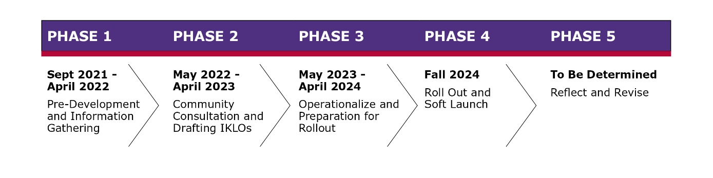

Phase 1
Sept 2021-April 2022 - Pre-Development and Information Gathering

Phase 2
May 2022-April 2023 - Community Consultation and Drafting IKLOs

Phase 3
May 2023-April 2024 - Operationalize and Preparation for Rollout

Phase 4
Fall 2024 - Roll Out and Soft Launch

Phase 5
To Be Determined - Reflect and Revise
Please note timelines are subject to change.

What supports are available?
- Jessica Pearce – Professor, Indigenous Curricula and Programs
- Rick McLean – Professor, Indigenous Studies
- Curriculum & Program Quality Consultants, Centre for Teaching & Learning
- Professional Development opportunities, Centre for Teaching & Learning

Contact Us
Please reach out if you have any questions or feedback by emailing IKLO@mohawkcollege.ca.

References
- Colleges & Institutes Canada. (n.d.). Indigenous Education Protocol for Colleges and Institutes.
- Mohawk College. (2021). Mohawk College Strategic Plan 2022 – 2025 at a glance.
- The Truth and Reconciliation Commission of Canada. (2015). Truth and Reconciliation Commission of Canada: Calls to Action

