Accessible
Learning Services

Emailing Confidential Academic Accommodation Plans Student Guide

IMPORTANT

You cannot access accommodations, including testing accommodations, without professors having a current CAAP.

Steps to Email your Confidential Academic Accommodation Plan (CAAP)

- Save a copy of your CAAP in a secure place on your computer. You will need your CAAP for two terms (semesters).

- Located your professors’ email addresses.

- Log into Mocomotion/My Student Account.
- Click on view timetable (left side of screen) and select your current term.
- Each course in your block is a link. Click on the course to find your professor’s name and email address.
- You can also find your professor’s name and contact information for each of your courses by going Mocomotion/E-learn tab at the top of the page.
- If you are a continuing education student, you may need to wait until the first night of class to obtain your instructor’s contact information in order to email your CAAP.

- Email your CAAP at the start of each term (see sample email on page 3).

Important Information

Please note the following regarding your CAAP:
- Your CAAP is now valid for a maximum of two terms (semesters) and has a specific expiry date.
- You can make revisions to your CAAP at any point during the term by making an appointment with your Accessibility Counsellor.
- Returning students do not need to book an appointment to renew a CAAP. If there are no changes or you are unable to locate your CAAP, please email als@mohawkcollege.ca to have your CAAP updated and/or replaced.

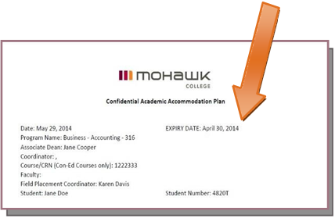

Student Responsibilities

Students are responsible for updating ad providing their CAAP to each professor. Students may request that ALS facilitate the distribution of their CAAP to appropriate professors. The CAAP represents a partnership between ALS, the student and the professor.

Writing Your Email

If you are not sure what to writ in your email, you can copy and paste this subject line and email body into your email.

Subject Line

Accessible Learning Services CAAP (name, student number, course name, course day and course time).

Body of Your Email

Hi, my name is (fill in your first and last name) and I am a student in your course: (fill in your course name and time).

I am receiving accommodations and support through Accessible Learning Services and have attached my CAAP for you to review.

Once you have received this email please confirm that you have received the attachment.

I would welcome the opportunity to discuss my accommodations with you. If you have any questions regarding this CAAP, please contact me or my Accessibility Counsellor.

Thank-you,

(Fill in your first and last name and student number)

Need help?

If you have additional questions or require assistance to email your CAAP, please contact Accessible Learning Services to receive support. You can reach Accessible Learning Services by phoning 905-575-2211 or emailing accessiblelearningservices@mohawkcollege.ca.

