CTL Course Master Template (UDL)
The Centre for Teaching & Learning (CTL) has designed a course master template for MyCanvas that embeds Universal Design for Learning (UDL). The template can be used as a starting point for new course builds or when redeveloping a course. The CTL course master template (UDL) is evidenced-based, has incorporated student feedback, and includes UDL. In addition, the template supports all delivery modalities.
This document outlines the purpose and key features of the CTL Course Master Template (UDL). If you have questions after reviewing this content, please connect with the Centre for Teaching & Learning.

Table of Contents
Table of Contents 1
Benefits of a Course Template 2
Universal Design for Learning (UDL) 2
Key Features 3
Importing the CTL Course Master Template (UDL) 8
References 9

Benefits of a Course Template
Benefits of using the CTL Master Course Template (UDL) include:
- Broad implementation of evidenced-based pedagogical approaches
- A consistent look and feel for courses to support easier and faster navigation by students
- A logical course layout that is consistent with the Learning Plan
- Reduced time and effort to organize course structure
- Easy access to College policies and MyCanvas support for students
Furthermore, Mohawk College has made a commitment to the inclusion of UDL within all of its learning environments. The CTL Master Course Template (UDL) has embedded a wide variety of UDL elements to both support inclusive and accessible student learning, and minimize additional effort and time to implement UDL in our online and learning spaces.

Universal Design for Learning (UDL)
UDL “is a curriculum design, development, and delivery framework used to create inclusive and accessible learning environments. The goal of UDL is to support creating masterful learners who are purposeful, motivated, resourceful, knowledgeable, strategic, and goal- directed” in any learning environment (2021, Mohawk College). Mohawk College is committed to UDL implementation and has embedded elements within the CTL Master Course Template (UDL) including:
- An accessible learning plan that can be used with adaptive technology and provides content options
- Communication options for students and instructors
- Course navigation instructions
- A UDL statement for students that outlines all of the UDL elements used in the course and information on what UDL is
- Content options (e.g. content available in HTML text and downloadable Microsoft Word document)
- Explicit course and content organization
- Multiple ways to access key course content and assessments
- Opportunities for learners to check their knowledge and self-evaluate their progress
- Prompts for multimedia resources including written and video instructions and resources
To learn more about UDL, please review Mohawk College’s UDL webpages.

Key Features
Highlights of the CTL Course Master Template (UDL) with supporting images are outlined below. If you have any questions about these elements, please connect with the Centre for Teaching & Learning.

Template Instructions
The template includes an unpublished instructor module that provides detailed instructions for Mohawk College educators. The Instructor Module outlines what information needs to be edited, how to duplicate content, and additional course development elements such iconography.
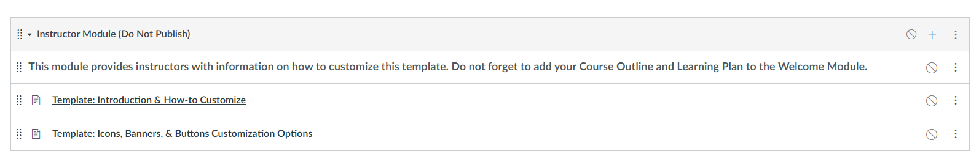

Content in HTML Format
To support content accessibility, the template promotes the use of HTML pages so that content can be read by ReadSpeaker (the MyCanvas built in text-to-speech tool). Content can still be added to course pages by using a “download here” feature so Word, PDF or alternate formats can also be included or posted directly within the weekly module.

Homepage
The template includes a homepage that prompts instructors to record a personal welcome video, a written welcome statement, and instructions on how to begin the course. Additional homepage features include custom quick-access buttons to improve course navigation and student technical support quick links.
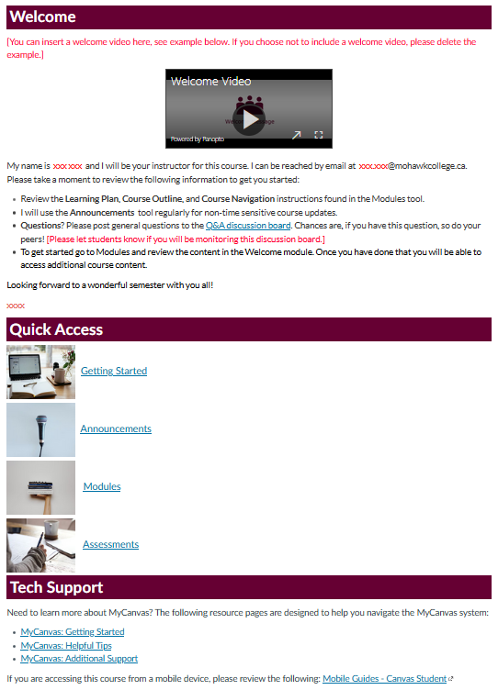

Welcome: Begin Here Module
The template provides a standard Welcome: Begin Here module that includes an instructor information page with the option to include an instructor video, complete course information and policies for students, and a UDL statement page. Users edit the page and input their own custom information where indicated with red text and/or as instructed in the module.
It is important that instructors link the Course Outline and Learning Plan in this module.
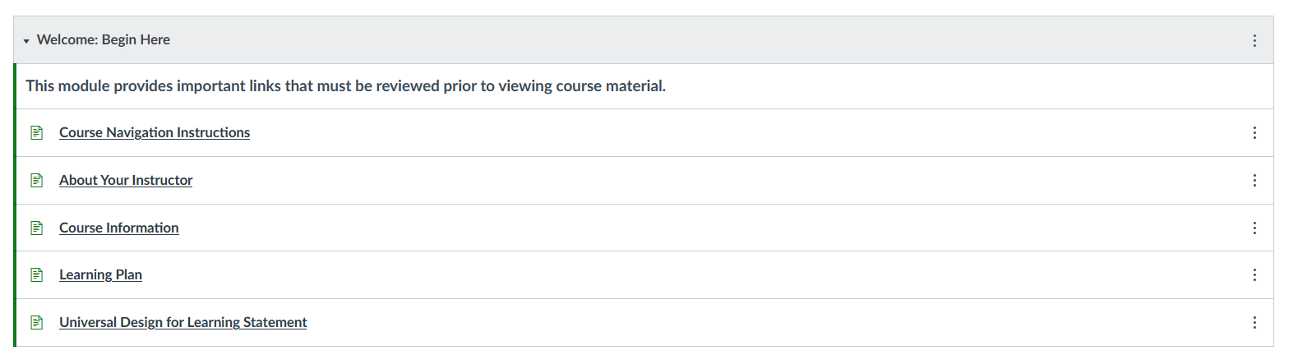

Course Resources Module
The Course Resources module provides a space for additional course resources that students will find beneficial to have easy and quick access to. The Course Q&A encourages students to post course-related questions in the discussion area so that other students can have access to the information. Having a course Q&A can help reduce instructor email congestion and provides a valuable communication option to both students and instructors.
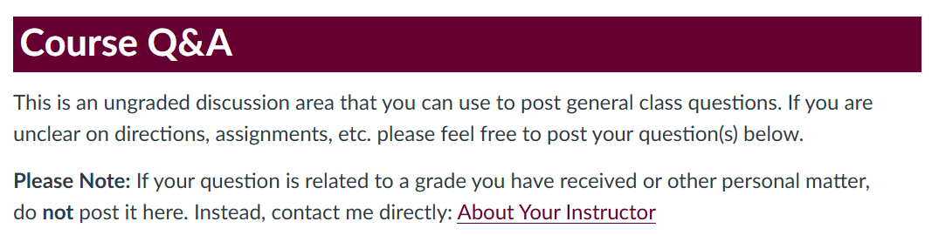
The module also includes a Glossary and instructions for students to effectively read their grades in the Grades tool.

Assessment Module
The CTL Course Master Template (UDL) includes an Assessment Module to ensure students are able to access key assessment content quickly and easily. The module includes a page that offers an overview of all of the course assessments, an optional assessment development template (with prompts for a video, assessment instructions, learning outcomes and rubric), and an overview of all course quiz information.
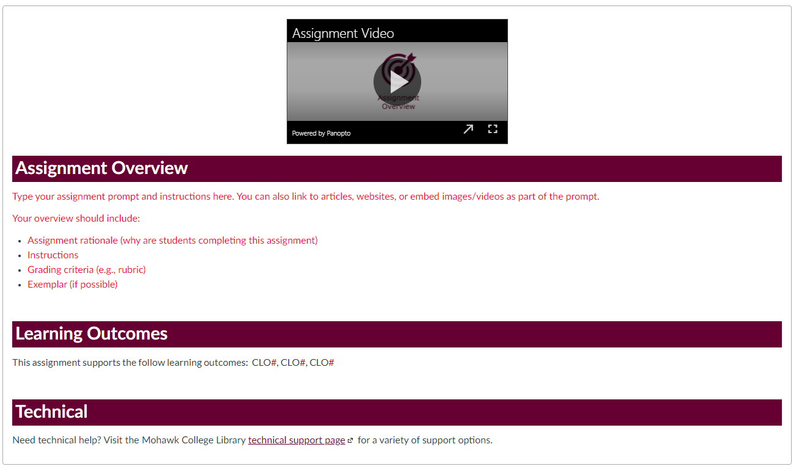
Assessment information for labs, placement, etc. can also be added to this module.

Weekly Content Modules

Layout Design Options
The CTL Course Master Template (UDL) offers two optional module layouts. Both options offer an overview for each module and a “Read, Watch, Do” structure. Both layout options include:
- A weekly overview that includes a module introduction, connections to the course learning outcomes and elements of performance, and expected time on task.
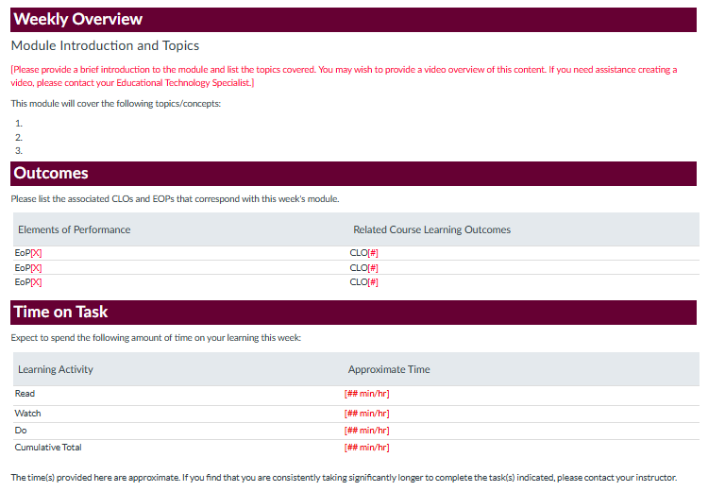
- Designated areas for course readings and multimedia resources. These Read and Watch spaces/pages provide an explicit layout for reading and viewing materials and prompts instructors to provide accurate citations and a resource overviews.
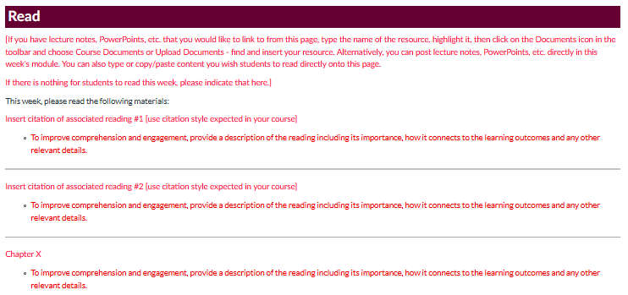
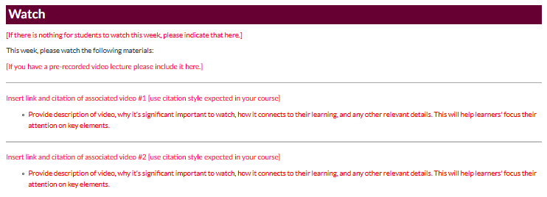
- The Do space/page provides space for the learning activities and assessments that students are to complete as part of the module.
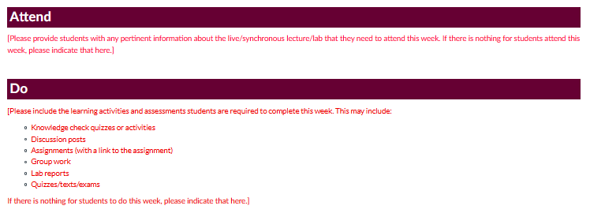

Importing the CTL Course Master Template (UDL)
The Canvas Commons is a learning object repository where Mohawk educators, using MyCanvas, can share learning resources and/or entire courses. The CTL Course Master Template (UDL) is available the MyCanvas Commons.
Mohawk College educators can import the CTL Course Master Template (UDL) into their course(s) using the following instructions:
- Enter the course shell that you want to add the CTL Course Master Template (UDL) to.
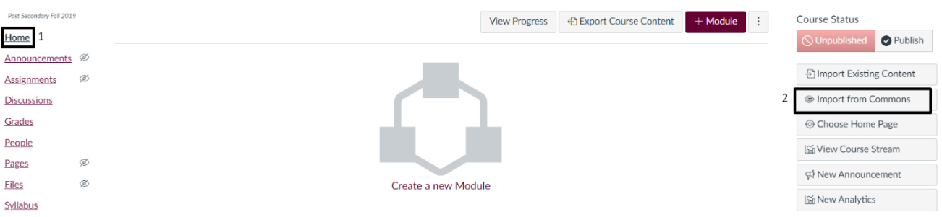
- From the course homepage, choose Import from Commons from the sidebar. Alternatively, you can choose to access the Commons directly from MyCanvas’ Global Navigation.

- In the Commons, type “CTL Course Master Template” into the search.
- Select “CTL Course Master Template (UDL)” to view the template details.
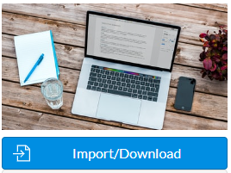
- Select the Import/Download button.
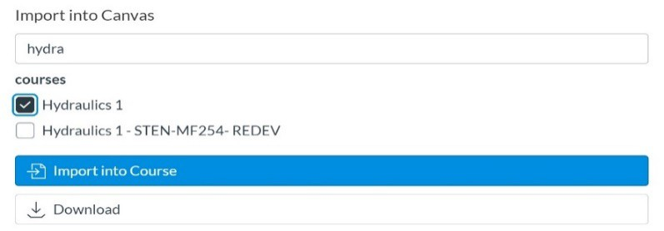
- Select the course shell or shells in which you want to import the course template, and select the Import into Course button. Alternatively, you can choose to download the course template as a .zip file to store it for future imports.
If you are a Mohawk College educator and need assistance with importing the CTL Course Master Template (UDL), please connect with the Centre for Teaching & Learning.

References
Mohawk College. (2021). Universal Design for Learning. Retrieved on May 6, 2021 from https://www.mohawkcollege.ca/employees/centre-for-teaching-learning/universal-design-for-learning/universal-design-for-0/course

