Universal Design for Learning Implementation
Universal Design for Learning (UDL) is meant to be a proactive approach to common and systemic learning barriers. Implementation makes learning more accessible, inclusive, and tractable for all students, while saving faculty time and effort.
Using the tabs on this page you will find a number of context specific UDL implementation ideas and initiatives.

UDL Course Assessment
To determine the UDL elements already in a course, or to determine where UDL can be added and obtain targeted resources, the UDL Course Assessment is a great place to start. To access the UDL Course Assessment, please use the link above or the image below.
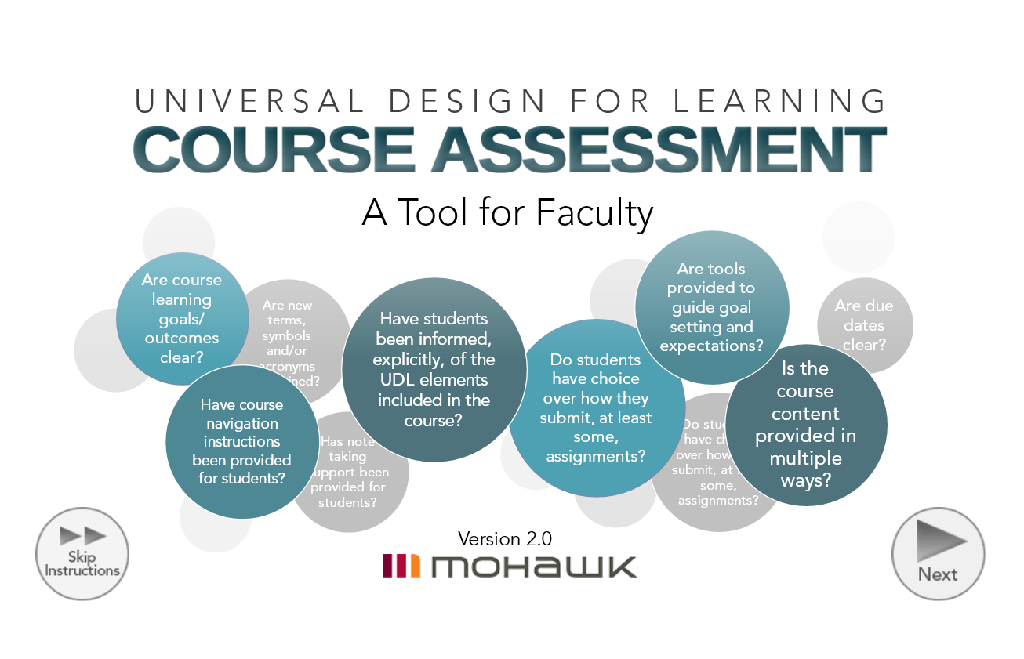

UDL Course Statement
By including a UDL statement on course sites and learning plans, learners will be made aware of what UDL elements have been included in the course, as well as the options that exist for them to gain course content and show what they know.
If you have implemented UDL in a course copy, paste and modify the UDL Statement below. Once the statement has been customized to a specific course it can be included on the course site, learning plan, as well as anywhere else you feel students will see it.
Universal Design for Learning
This course has been designed using Universal Design for Learning guidelines. The following elements have been incorporated into this course to support greater inclusion and access:
- 100% additional time has been added to quizzes and tests.
- Lecture presentations are offered in advance of class.
- Varied assessment methods throughout the course.
- Course content and resources are available in a variety of formats.
- Multimedia learning resources.
- Closed captioning or a transcript provided for videos.

MyCanvas Course Master Template
The Centre for Teaching & Learning has designed a Course Master Template with UDL elements for MyCanvas. The template can be used by Mohawk College educators as a starting point for new course builds or when redeveloping a course. The CTL Course Master Template (UDL) is evidenced-based, has incorporated student feedback, and includes a wide range of UDL elements. In addition, the template is fully customizable and is supportive of all delivery modalities.
The CTL Course Master Template (UDL) document outlines the purpose and key features of the template. If you have questions after reviewing this resource, please connect with the Centre for Teaching & Learning.

Additional Information
If you are interested in implementing UDL, need support to customize the UDL Statement for your course(s) or have implementation ideas, please connect with Darla Benton Kearney, Teaching & Learning Consultant – UDL, in the Centre for Teaching & Learning, at darla.benton@mohawkcollege.ca or extension 3688.

Additional Time for Quizzes/Tests/Exams
Including additional time on quizzes/tests/exams allows all learners to read questions more carefully, evaluate their answers thoroughly, complete the assessment with less anxiety related to time, and can provide a better reflection of their content knowledge. Wherever possible, applying UDL guidelines to course quizzes/tests/exams can provide a supportive evaluation environment for all students.
Additional time for testing is one of the most common disability related accommodations at Mohawk College, as it supports a wide-range of disability types and needs. While students registered with Accessible Learning Services may continue to book tests in the Testing Centre for other disability related testing accommodations, proactively including additional time to quizzes/tests/exams can reduce time and effort of arranging additional time accommodations for both educators and students.
Sometimes the content being assessed must be done so in a specific amount of time (for example because of a clearly defined and articulated industry standard or demonstrating knowledge within a specified time is an explicit learning outcome of a course). However, when this is not the case or when a specific disability related accommodation is required, educators may wish to proactively extend quiz/test/exam times to ensure all students have the time they need to fully show what they know without the additional barrier of limited time. Proactively including additional time does not have to mean for all quizzes, tests, and exams. Faculty can determine which of these assessments would be best suited to including additional time as a UDL element.
As the most common additional time accommodations are typically 50% to 100%. To ensure as many students are supported as possible, and to limit additional effort, the recommendation is to add 100% additional time to quizzes/tests/exams when possible. Ideally, when suitable, unlimited time can be offered. Once the appropriate additional time has been determined, it is essential that learners be informed that that additional time has already been added to their quizzes/tests/exams. The Implementation section below offers a statement educators can modify and include anywhere quiz/test/exam information is included in a course.

Implementation
To implement:
- Determine where additional time can be proactively added to the quizzes, tests, and/or exams in the course.
- Determine the appropriate length of additional time for the assessment(s).
- Add the additional time, or unlimited time where appropriate, to the quiz/test/exam.
- Modify the statement below and include the statement anywhere quiz/test/exam information is shared with learners (for example, on the course learning plan, the online course overview page, test instructions, etc.).
Additional Time for Online Course Quizzes/Tests/Exams
The quizzes/tests/exams in this course have been designed using Universal Design for Learning guidelines and (give the percentage) additional time has already been added to each quiz/test/exam in support of all students.

Content Options
UDL works to provide students with options to obtain course content in the way that is the most supportive and beneficial to their learning. Additionally, there are learners who require or would benefit from alternate formats. However, gaining alternate formats for course content can be a time-consuming barrier for students, as well as educators. Proactively providing course content in multiple formats, is supportive of all learners and can save educators time.

Implementation
There are a number of practical ways to provide content options within a course. Ideally, all course content would be proactively provided in at least two formats. Options for providing multiple formats may include:
- Content in the HTML editor and a link to Word versions, and/or PDF
- PowerPoint presentations with PDF versions
- Captioned videos posted with a transcript
To implement:
- Create the course content in whatever format you choose.
- Copy and paste the content into another format (for example, copy and paste content from a Word document into the HTML editor in the online course site), or save the document as another file type (for example, saving a PowerPoint as a PDF).
- Provide all content options to students and explicitly tell them where the materials are and how to access them.
If you would like to include links to additional formats, or caption your videos, contact your Educational Technology Specialist in the Centre for Teaching & Learning.
To support equity, inclusion and access, it is important that course content is accessible to all learners. To learn more about how to make documents and presentations accessible, review the Accessible Documents and Alternate Format resources on the Accessibility Tool and Resources webpage.

Open Educational Resources
Open Educational Resources (OERs) are another easy way to provide a wide variety of content options with minimal effort; OERs have up to nine different formats (for example PDF, HTMLBook, etc.) for students to choose from.
To learn more about OERs and find suitable course materials you can search Ontario’s Open Library website. If OERs are new to you, you may also wish to review the Learning Portal About OER webpage. If you have questions regarding the use of OERs you can review the Mohawk College Library Open Education webpage, or connect with the Mohawk College Library.

LinkedIn Learning
LinkedIn Learning has a variety of learning material options for learners to choose from (for example, transcripts of videos or captioning) while providing multimedia resources suitable for higher education courses.
To learn more about LinkedIn Learning at Mohawk College, including how to access materials and gain support if you need it, review the LinkedIn Learning website.

Course Navigation Instructions
Providing learners with explicit information at the start of a course is an ideal way to set course expectations, help students quickly find key information, and offer directions regarding how to proceed through the course.

Implementation
The following outline suggests headings and content ideas that may guide the development of course navigation instructions.

Course Introduction
This section could include:
- An overview of the course and assessment methods
- Course expectations
- A link to the course outline
- A link to the learning plan
- A UDL statement that includes all of the UDL elements used in the course (for a sample UDL statement, please reference the UDL Implementation landing page)
- Any information regarding Accessible Learning Services and obtaining disability related accommodations in the course.

Faculty Introduction
This section could include:
- A welcome message, which may be accompanied with a faculty photo or delivered via video
- Faculty contact information, contact preferences, and/or office hours

Accessing Content
This section could include explanations of:
- How the course is laid out (for example by week, by module, or by topic)
- Other sections included (for example Assessments, Additional Resources, etc.)
- What order the content should be accessed (for example first, second, third, etc.)
The information above is meant to provide options to develop course navigation instructions and can be altered to meet the specific needs of a course.

Interim Due Dates
Executive functioning skills, including time management and organization, can impact students’ ability to plan assignments and complete large assignments. Learners in the first or second semester of their program can often benefit from explicit support to plan and organize their assignments. In addition, providing executive functioning support can reduce issues exacerbated by late assignments for both educators and learners.
To assist learners to produce the most accurate reflection of their knowledge and to ensure educators can accurately assess the learning outcome(s), consider providing interim due dates on assignment outlines and/or course learning plan. For example if an assignment is to be completed in three weeks, educators can outline what elements should be completed in the first week, what should be completed in the second week, and what needs to be done to finish the assignment and submit it in the third week.
If educators are able, ungraded feedback can be given for each interim date. Additionally, resources and supports can be offered for each portion of the assignment, such as a link to the Library for research support in the first week or the Writing Centre for editing help in the final week.

Implementation
- Identify which assessments would benefit from interim due dates.
- Determine steps and resources required to complete the assignment and determine a timeline of interim dates.
- Provide the timeline/interim due dates on the assignment outline, the course learning plan and/or wherever assignment information is provided.

Language and Symbol Options
Many learners can find new, subject specific language and symbols challenging. To support all learners’ equitable participation and inclusion in a course, a glossary or legend or common terms, acronyms and/or symbols is very helpful. In addition, offering a glossary or legend of commonly used terms, acronyms, and/or symbols provides an accurate, time saving resource for learners and makes delivering content more efficient. In addition, this type of reference document can serve as a study aid and/or support more effective note taking.

Implementation
There are a few ways to create a glossary or legend for language, symbols, acronyms, etc. for your course:
- Use an open document or page in the online course and list the common language/symbol/acronyms for the course, post it, and advise students that it exists and where.
- Develop a collaborative document within the online course site using discussions, pages, or collaboration functions and then invite learners to contribute to the glossary or legend as they come across language/symbol/acronyms that would benefit from clarification throughout the course.
- Recommend students create and update their own dictionary of language/symbol/acronyms to refer to as they work through course content throughout the semester. To guide this process, educators can create a template for learners to use to structure their glossary/legend for the course.

Note Taking Support
Clear and concise notes support learners to prepare for lessons and learning activities, study more efficiently, and complete assessments more effectively. However, many students struggle with effective note taking and do not end up with the course resources that will serve them best. In addition, note taking accommodations are among of the most common for students with disabilities, and it can be challenging to implement accommodations for this need, for both learners and educators.
There are a number of ways educators can proactively support all students to have complete and comprehensive course notes, including:
- Posting lesson/course notes
- Posting lesson presentations
- Crowdsourcing lesson notes
- Audio recording

Posting Lesson Notes
By posting lesson/course notes to the online course site in advance of class, learners can proactively review lesson content and prepare for class. Providing notes in advance also removes the individualized accommodation barriers for students with disabilities, as well as educators.
Lesson notes can include:
- Complete lesson notes
- Notes that include blank spaces where students can complete notes during the class
- A series of questions about the lesson that learners can answer in class and/or using weekly resources/readings
- A detailed outline of the lesson, with completed notes to be posted after the class
As indicated on the Content Options webpage, greatest inclusion is achieved when content is provided in at least two formats. These formats could include copying and pasting the notes into the HTML editor and proving a link to a Word or PDF document. If educators require support to include links to downloadable Word documents, connect with the Educational Technology Specialist for your area.

Implementation
- Post lesson notes, in advance, to the online course site.
  - The posted notes can be organized; however, the content is organized, for example by week, module or chapter.
- Advise students that lesson notes have been posted and provide them with explicit instructions on how to use the notes effectively.
  - The instructions could include reviewing the notes prior to class, printing or downloading the notes to complete them in class, using the notes effectively to study, etc.

Posting Lesson Presentations
Similar to posting lesson notes, lesson presentations can support students with note taking and preparing for class.

Implementation
- Post the lesson presentations, in advance, to the online course site.
  - The presentations can be organized however the content is organized, for example by week, module or chapter.
- Advise students that lesson presentations have been posted and provide them with explicit instructions on how to use the presentations effectively.
  - This could include reviewing the presentations prior to class, printing or downloading the presentations to write additional notes from lecture directly on the slides, etc.
To support inclusion and the accessibility needs of all learners, posting the lesson notes in two formats is ideal. For example, include the PowerPoint presentation and a link to a PDF version or creating a video of the lesson and providing the original presentation as well.

Crowdsourcing Lecture Notes
Crowdsourcing of lecture notes was an idea originally developed by Dr. David Rose from Harvard. It was designed within the framework of UDL to support the note taking needs of learners and to minimize note taking efforts of educators. Crowdsourcing lecture notes has the capacity to:
- Support all students to double check content and improve their notes and note taking skills
- Encourage every learner to have complete and effective study notes, with minimal additional effort for the educator
- Allow educators to see what students are taking away from lessons
- Reduce the need for peer note taking support for students with disability related note taking accommodations
Crowdsourcing lecture notes involves having learners, who are attending lessons and taking notes anyway, to share them. This is most easily done by students posting their notes to a designated space on the online course site. Once posted, any learner in the course can access the notes and use them to study, correct their notes, catch up on missed classes, etc.

Implementation
There are a variety of ways that educators can provide space for crowdsourced lecture notes in the online course environment:
- Create a collaboration page for each module/unit where students can post their notes from each lesson.
- Recommend the Discussion area be used to post notes.
  - In order to let students add documents, create posts, and/or edit their content permission needs to be granted. To do this, in Settings, click on More Options at the bottom of the page and check the boxes that state “Let students attach files” and/or “Let students create discussion posts” and “Let students edit or delete their own discussion posts”.
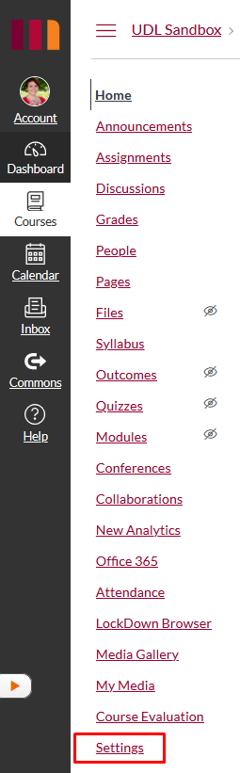
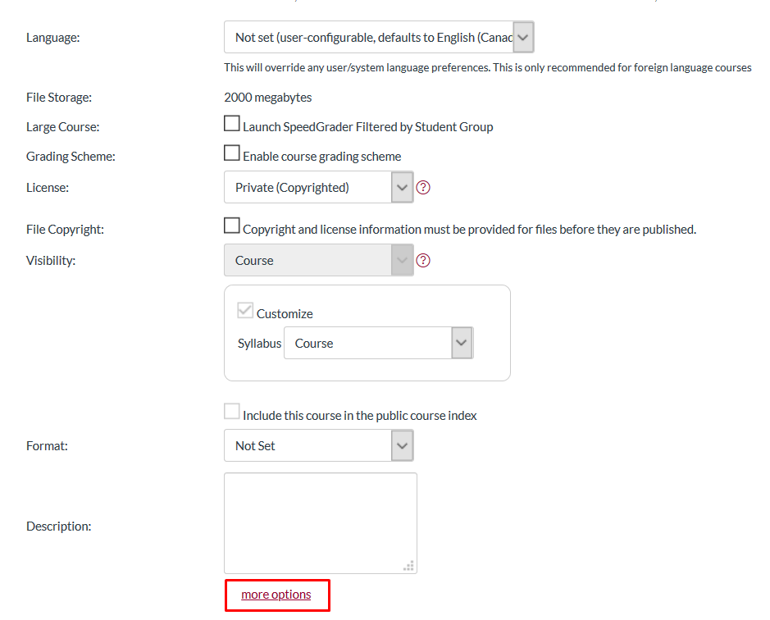
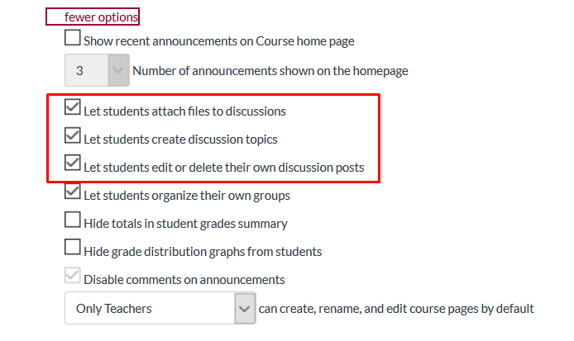
- Use the Conferences tool to open a space for notes during and after lessons.
- Develop an editable Page for each module/unit where students can post their notes from each lesson.
  - Be sure to provide a clear and concise title for each lesson note page and ensure that both educators and learners can edit the pages by using the Options menu in the Pages tab.
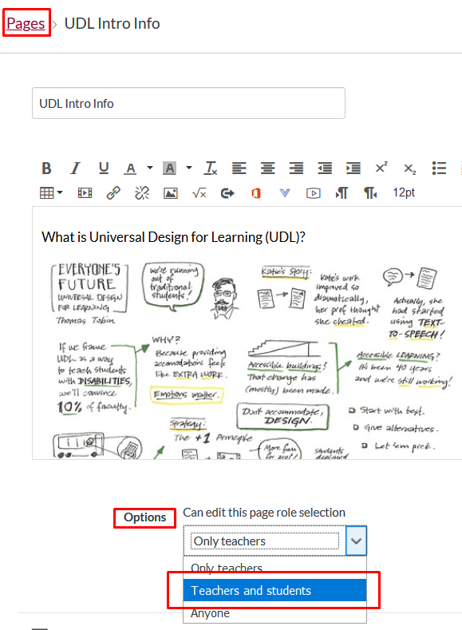
If you have questions regarding which would be the best tool to offer crowdsourcing lecture notes within your course, connect with the Educational Technology Specialist for your area.
Once you have determined the best way to include crowdsourcing lecture notes as a UDL initiative in your course, inform learners and encourage them to post their notes. Some educators have found it helpful to offer an incentive for students to share notes by offering a reference letter or encouraging students to apply for the “Student Services - Note Taker – Crowdsourcing” co-curricular record credit when they have completed 15 hours or more of note taking in a course.

Audio Recording
Occasionally educators may get a request or accommodation letter for audio recording lectures. However, supporting this request of fulfilling this accommodation can have challenges. Given learning activities, group discussions, personal sharing, etc. it can be difficult to gain an ideal recording of the lecture content. If these are challenges in your course, you may wish to provide audio recording options to all students in support of improved note taking and access to course content after the lesson is over.

Implementation
When audio recording lectures will be supportive of note taking efforts, there are options that educators can employ to improve the ability of learners to get audio content that is easy to listen and study from. Educators can:
- Create a lecture overview video that includes key lecture information.
  - This option creates both an audio and visual resource that supports not only note taking, but also providing multiple means of representation.
  - Kaltura has an auto-caption function that can be manually corrected for accuracy and can be integrated into the online course site.
- Provide an audio overview of the lesson and post it to the course site in the folder of the week it was delivered.
- If you are using PowerPoint, create an audio overview for each slide.
- Provide comprehensive lecture notes in Word or HTML in the online course site, so that students can use the text-to-speech tools to listen to the content.
To learn more about the ways that online course tools can be leveraged to support audio recording of lectures, connect with the Educational Technology Specialist for your area.

Online Course Layout
An explicit and well organized online course layout allows learners to access course content quickly and easily, with less confusion and frustration. While there is not one ideal course layout that is perfect for every course or everyone, there are some general UDL considerations to apply to online course organization to make it easier for learners to access online curriculum and assessments.

Implementation
When designing the online course layout, consider:
- Providing navigation instructions.
  - Letting students know how to access course content, what is important, and when it is most relevant makes learners able to access content more effectively. For more information, see the Course Navigation Instructions webpage.
- Providing multiple ways for learners to access key information.
  - Including key information such as assignment due dates, contact information, placement materials, etc. in a few different locations will support students finding the content easily and referring to it often. For example, assignment outlines and rubrics can be posted in the week in which they are issued and/or due, as well as in a separate content folder.
- Matching the learning plan to the online course content headings.
  - Having the learning plan match the content section in the online course, as well as any other sections that offer course dates, allows learners to more easily and quickly reference course materials and assessment information. For example, if the learning plan is divided by week and/or date, the content headings in the online course should also be divided by week and/or date. If the learning plan is divided by module, the online content should match.
- Reflecting on past deliveries of the course, or past course layouts.
  - Reflecting on deliveries through a UDL lens can lead to improvements in course layout. For example, if students had difficulty finding specific content, this would be good information to duplicate elsewhere in the course. Or, if learners missed a particular assessment, organizing the layout to draw more attention to assessment information would be beneficial.
While there is not one course layout that is ideal for all courses, the following format is one that a number of educators have found beneficial (subheadings are identified in bold text).

Course Information
This folder may contain:
- Getting Started which can include course navigation instructions
- Course Requirements
- Instructor Information
- Course Outline
- Learning Plan
- Universal Design for Learning
  - See the UDL Implementation landing page for more information regarding a UDL Statement for courses.

Course Content
Ideally, the folders in course content will be identified as they are on the learning plan.
Subheadings in course content may include:
- Read
  - Required
    - Include required readings for the week and/or lecture notes.
  - Recommended or Supplemental (if any)
    - Include the additional readings that offer an alternate way of understanding key concepts, or readings that support deepening knowledge.
- Watch
  - Required
    - Include required videos for the week and/or lecture presentations.
  - Recommended or Supplemental (if any)
    - Include the additional videos that offer an alternate way of understanding key concepts, or videos that support deepening knowledge.
- Do
  - Include any course activities or lab work that needs to be completed for the week.
  - Include assessment information in this section.
The above format can be modified to meet the needs of individual courses. Some courses may include a separate folder for assignments, readings, lab content, and placement information to support easy access to key resources.
Additional folders could include:

Assignments
All assignment information and grading rubrics can be included in one folder to provide students an alternate way to access this key information.

Readings/Videos/Lectures
All readings, videos or lectures, identified as they are in the content section and learning plan, are included in one folder to give additional access to this content.

Recommended Tutorials
Additional course specific tutorials, or more general options such as those for plagiarism or the online course, can be included in this section to provide students with additional resources to be successful in their studies.
An easy way to obtain this online course layout is to import the CTL Course Master Template (UDL) into your course. You can learn more about the template by reviewing the UDL Implementation landing page and/or the CTL Course Master Template (UDL) document.

Online Student Accessibility and Preference Instructions
Learners benefit from options that allow them to change their online learning environment to meet their individual learning needs and/or preferences. Identifying the accessibility and preference options that exist in the online course environment empowers all students to have control and responsibility over aspects of their learning. Learners need to be informed of how their learning preferences can be met in the online course space.

Implementation
In order to offer online accessibility and learning environment preference instructions, reviewing the accessibility features specific to Canvas is a great place to start. The following links offer resources to support creating adaptable and accessible content:
- How do I use the Accessibility Checker in the Rich Content Editor as an instructor?
- Accessibility within Studio
- ReadSpeaker in Canvas for Faculty video
- General accessibility is supported by the Tools and Resources section of the Accessibility website
Once reviewed, adding the accessibility and learning options to the online course will support learners to adjust the content to meet their needs.
Post the following links and/or video to your online course page and draw students’ attention to these accessibility and preference options:
- Canvas Profile and User Settings
- ReadSpeaker in Canvas for Faculty video or the ReadSpeaker Getting Started guide

Rubrics and UDL
Well-constructed rubrics allow all learners to better understand the outcomes of the assessment, how they will be graded and plan their time accordingly to complete the work to the best of their ability. In addition, when assignment expectations are clearly defined on a rubric, grading can be more efficient and concise.
UDL does not have an ideal rubric type, that is to say, the ideal rubric for UDL is one that accurately supports the measurement of learner knowledge of the course learning outcome(s) without constricting the options of how a learner can show what they know. A rubric designed with UDL in mind:
- Is based on the learning outcome(s) being measured, not the assessment or submission method.
- Is provided to learners with the assignment outline to ensure they know how they will be graded, and what knowledge is being assessed.
- Applies to all of the submission options offered to the learners (see the Submission Options webpage for more information).
Educators sometimes feel that they need to have a different rubric for each way a student can submit an assessment, but this is not the case. If the rubric is based on evaluating the learning outcome(s) the assessment is for, and worded appropriately for a variety of submission options, one rubric will be able to support a larger variety of assessment submission options. For example, if your assessment allows learners to choose if they would like to write an essay, create a video presentation, or develop a detailed infographic, including spelling and grammar in the rubric will not support all possible submission options. Instead, using a phrase like “clearly articulate” would encompass all of the submission options offered making one rubric sufficient and useable for all submissions.

Implementation
To implement:
- Determine the right type of rubric for your course and your assessments (see the Rubric Design webpage for more information).
- Adapt the rubric to meet the specific needs of the learning outcome(s) being assessed.
- Post the rubric with the assessment and draw learners’ attention to the rubric.
More information regarding how to create rubrics can be found on the Centre for Teaching & Learning’s Rubric Design webpage.

Submission Options
Providing options regarding how assessments are submitted allows learners to leverage their strengths to demonstrate their knowledge in the best way they can, while supporting educators to more accurately assess what a student knows. Removing barriers that are not related to the learning outcome(s) and allowing options regarding how a student can meet the learning outcome(s) supports a more inclusive and equitable learning environment.
While it is not always possible to provide options to learners about how they submit every assignment in the course, offering even one submission option will improve learner engagement and allow for multiple means of action and expression.
When creating the assessment rubric it is important to ensure it is based on the learning outcome(s) the assessment is designed to measure, as opposed to the submission method. For more information on creating rubrics with UDL in mind, review the Rubrics with UDL webpage.

Implementation
To implement:
- Consider an assessment method already in your curriculum and determine if there are alternate ways learners could demonstrate the same knowledge, but in another format. Here are just a few examples:
  - Discussion posts could be done in writing, audio or video
  - Essays could be submitted in writing, a comprehensive infographic or created website
  - Presentations could be done in person or via video.
  - Reflective journals could be completed in writing, using a blog, a video log, or as photographs or works of art.
- Determine which submission options are feasible, taking into consideration marking time, grade value of the assessment, etc. and eliminate the ones that would not be possible given the course context.
- Provide explicit instructions on the assignment outline of the submission options available. Offering exemplars of assignment submissions are ideal.

