Universal Design for Learning

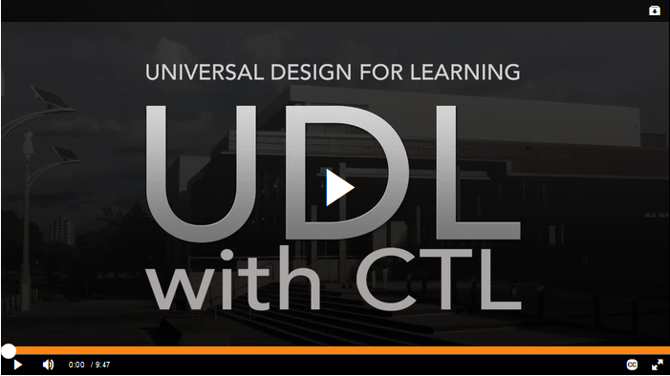

What is Universal Design for Learning?
Universal Design for Learning (UDL) is a curriculum design, development, and delivery framework used to create equitable, inclusive and accessible learning environments. The goal of UDL is to support creating masterful learners who are purposeful, motivated, resourceful, knowledgeable, strategic, and goal-directed.
UDL guidelines are based on three primary brain networks:
- Affective
- Recognition
- Strategic
Each network is identified by a principle to guide design, development, and delivery in practice:
- Multiple means of engagement
- Multiple means of representation
- Multiple means of action and expression
Each network contains three checkpoints (nine in total) that emphasize learner diversity that could either present barriers to, or opportunities for, learning. The checkpoints are as follows:
- Multiple Means of Engagement
  - Options for recruiting interest
  - Options for sustaining effort and persistence
  - Options for self-regulation
- Multiple Means of Representation
  - Options for perception
  - Options for language, math and symbols
  - Options for comprehension
- Multiple Means of Action and Expression
  - Options for physical action
  - Options for expression and communication
  - Options for executive functions
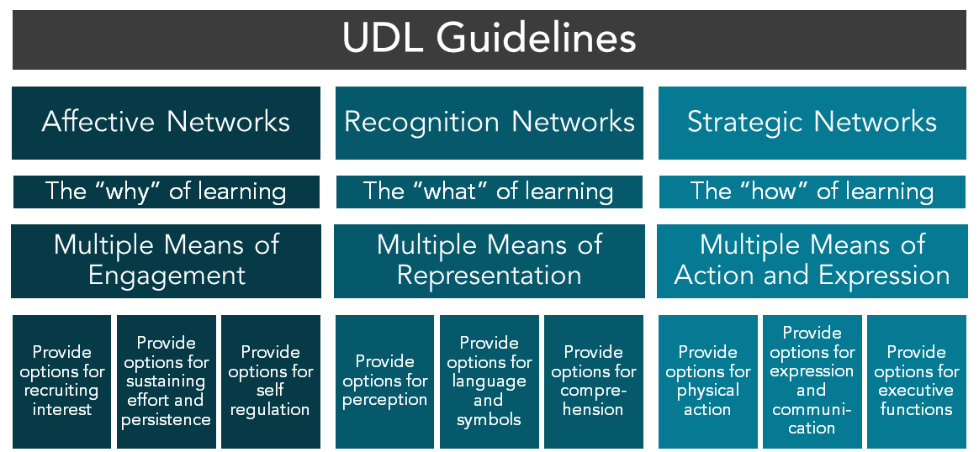
The graphic organizer below offers a visual representation of the UDL Guidelines used at Mohawk College.
You can also access the UDL Guidelines as text: UDL Guidelines in Word or UDL Guidelines in PDF.
Use the tabs on this page to explore UDL at Mohawk College, including information for educators, implementation ideas, and useful resources.

UDL for Equity, Diversity and Inclusion
UDL gives educators a comprehensive framework to centre equity-deserving students in our learning spaces. Because of its capacity to support all learners, Mohawk College has built UDL into its Equity, Diversity and Inclusion (EDI) Action Plan.
To learn more about Mohawk College’s commitment to EDI and how UDL supports these goals, review Mohawk’s Commitments and Action Plan webpages.

UDL Standard
Based on the data obtained through the 2017-2018 Universal Design for Learning for Technology-enabled Post-secondary Courses at Mohawk College research project (access the report in Word), a UDL Standard for Mohawk College was developed. The goal of a college-wide standard for UDL implementation is to promote the advancement of Mohawk College’s commitment to equity, inclusion and access in all learning environments.
The video below explains the UDL Standard and its use in our context.
The UDL Standard is not prescriptive, and is meant to provide consideration options to support the design, development, and delivery of curriculum. Review the UDL Standard, in one of the formats included below, to determine the ideal way to implement UDL in your context.
Access the UDL Standard as a Word document or Access the UDL Standard as a PDF document

Universal Design for Learning Contact Information
Darla Benton Kearney is the Teaching & Learning Consultant – UDL, in the Centre for Teaching & Learning at Mohawk College. For UDL support, connect with Darla at darla.benton@mohawkcollege.ca or extension 3688.

