UDL Standard for Mohawk College

Introduction
Universal Design for Learning (UDL) is a curriculum design, development and delivery framework used to create inclusive, equitable and accessible learning environments for diverse student populations.
Figure 1 – UDL Guidelines
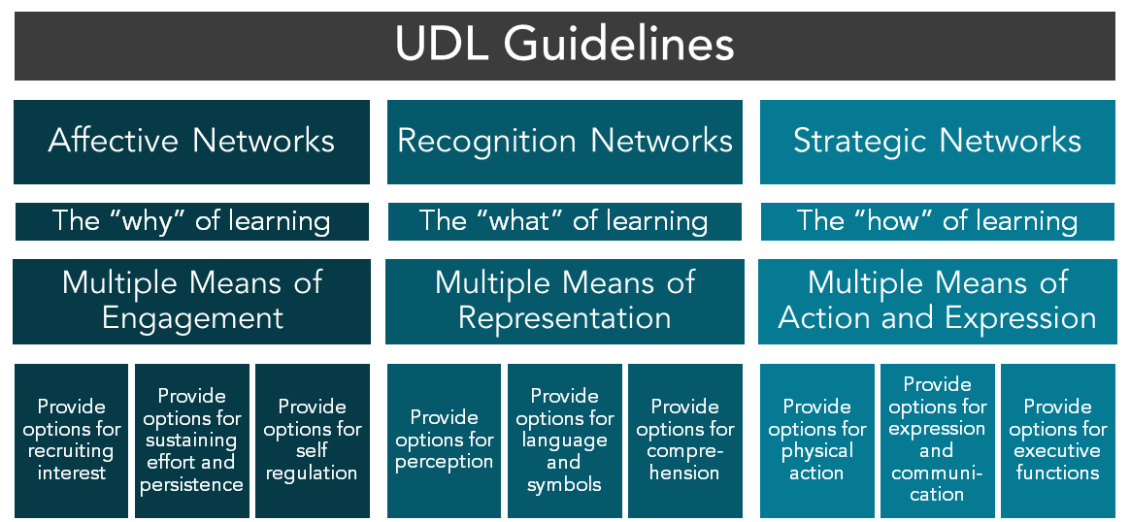
The graphic organizer below offers a visual representation of the UDL Guidelines used at Mohawk College. You can also access the UDL Guidelines as text: UDL Guidelines in Word or UDL Guidelines in PDF. To learn more about UDL at Mohawk College, access the UDL webpages.
Mohawk College’s Program Quality Policy outlines the College’s commitment to exemplary academic standards through quality program delivery. In addition, Mohawk’s Commitments and Action Plan webpages outline its dedication to ensuring equitable and inclusive access to education for all learners. Research identifies UDL as a highly effective practice to meet Mohawk College’s quality standards and support its educational equity and inclusion targets.
UDL is not prescriptive, but rather encourages the consideration of options that remove learning barriers and promotes equity and inclusion. The development of a UDL Standard for Mohawk College supports:
- Advancing Mohawk College’s commitment to accessibility, equity and inclusion.
- Meeting, or exceeding, the Accessibility for Ontarians with Disabilities Act (AODA) educational standards.
- Facilitating a culture shift in design, development, and delivery of education by implementing UDL in teaching, learning and services.

UDL Standard
The UDL Standard for Mohawk College includes UDL elements that are:
- Based on faculty and student data obtained during the Universal Design for Learning for Technology-enabled Post-secondary Courses at Mohawk College research project.
- Tied to the UDL guidelines and principles developed by the Centre for Applied Special Technology (CAST).
- Supportive of Mohawk College’s EDI Action Plan.
- Integrated into by Mohawk College’s learning management system (LMS).
- Supported by Mohawk College’s Academic Operations, Program Quality Policy, EDI Action Plan, Accessible Learning Services and Centre for Teaching & Learning.
The application of UDL is dependent on a variety of factors including core competencies, learning outcomes, course content, delivery method(s), learner demographics and capabilities of the LMS. Broadly, the UDL Standard recommends that:
- All employees be encouraged to implement UDL in their context as a means to meet Mohawk College’s EDI targets and provincial AODA standards for education.
- UDL Guidelines are considered and implemented in curriculum design, development and delivery at Mohawk College.
- Mohawk College provide ongoing support for UDL education and implementation within the institution.
Specifically, the UDL Standard asks educators to consider the following UDL elements and options identified below.

UDL Considerations for Course Design:
- Designing course resources that are concise and explicit, and ensuring course expectations include:
- Learning outcomes and learning goals
- Learning plan with clear due dates
- Course navigation instructions
- Assignment outlines/instructions
- Creating online learning environments that have clear layouts and include access to course content from multiple areas in the course.
- Including varied assessment methods, that include a variety of options for learners to demonstrate their knowledge.

UDL Considerations for Course Development:
- Producing course content that:
- Is provided in multiple ways
- Is concise, explicit and accessible
- Explains terms, symbols and/or acronyms
- Engages students’ prior knowledge
- Embeds links to learning materials throughout the course content to create easy access to information
- Allows the completion of, at least some, course content at students’ pace and/or in their preferred order
- Constructing assessments that:
- Accurately evaluate the course learning outcomes and goals
- Build on the new skills students acquire
- Provide multiple opportunities for students to demonstrate their knowledge
- Have clear instructions offered in an inclusive and supportive way
- Encouraging independent student responsibilities.

UDL Considerations for Course Delivery:
- Providing note-taking support.
- Including interactive learning activities.
- Offering options for students to work individually, in pairs, or in groups.
- Encouraging communication between students and with faculty through a variety of means.
- Evaluating knowledge by:
- Offering choices regarding how students submit, at least some, assignments
- Proactively adding additional time to quizzes and tests, or not timing quizzes or tests
- Varying assessment methods throughout the duration of a course
- Prompting students regarding due dates and/or giving interim due dates for large assignments.
As UDL implementation is a dynamic process, so is Mohawk College’s UDL Standard. The UDL Standard is updated as technology evolves, as UDL implementation increases and as more UDL research and data is obtained.

Resources
The UDL Standard for Mohawk College was developed using:
- Research from the 2017-2018 Universal Design for Learning for Technology-enabled Post-secondary Courses at Mohawk College eCampusOntario research project (access the report in Word).
- The Mohawk College Program Quality Policy.
- Universal design for learning: Theory and practice by A. Meyer, D. H. Rose and D. Gordon
To support the implementation of UDL in teaching and learning approaches, Mohawk College is committed to providing professional development, consultation opportunities, and resources to educators. The UDL webpages, provide a starting point to access UDL implementation ideas, educator support, resources and contact information to gain ongoing support. In addition, the UDL Course Assessment is available. The UDL Course Assessment is a self-assessment tool for educators to determine the UDL elements they currently employ, as well as offer targeting resources for additional UDL implementation.

