The Writing Centre
Argumentative Essay

An argumentative essay is sometimes called a persuasive essay. This kind of essay expresses an opinion about a contested issue. As the writer, you must take a position and persuade the reader to agree with your opinion by using all relevant research and strong, logical reasons to support your argument. The following outline demonstrates one simple way that such an essay may be conceived.
Step 1: Brainstorm Ideas
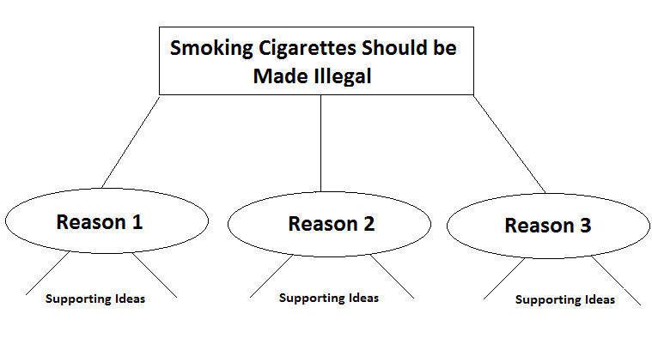
Step 2: Create an Outline
INTRODUCTION: Your opening statement should 1) grab your audience’s attention and 2) give the audience a sense of the stakes of the issue. You may pose a provocative question, state an alarming fact, share a revealing anecdote, etc.

Lead:________________________________________________________________________________________________________________________________________

THESIS STATEMENT: State your position clearly, including not only the topic of your essay but also the controlling idea (your approach to or opinion on the topic). You may also list the reasons to be provided in your body paragraphs to give the audience a “map” of your argument.
Smoking should be made illegal because: __________________,____________________, and____________________.

BODY PARAGRAPHS: Your body paragraphs should provide your reasoning for the audience. Support each assertion with evidence from research: facts, illustrations, quotations from sources, etc. Draw logical conclusions from the evidence. Depending in on your audience’s needs, you may order your reasons according to strength. Proceed from least to most convincing for a strong finish!

Reason 1
Topic sentence: The first reason smoking should be made illegal is ___________________________________________
1. Fact /Example 1
2. Fact /Example 2
3. Fact / Example 3

Concluding/Transition Sentence: _________________________________________________________ _____________

Reason 2
Topic Sentence: The second reason smoking should be made illegal is _______________________________________
1. Fact /Example 1
2. Fact/Example 2
3. Fact / Example 3

Concluding/Transition Sentence: ___________________________________________________________________

Reason 3
Topic Sentence: The last reason smoking should be made illegal is ________________________________________
1. Fact /Example 1
2. Fact /Example 2
3. Fact / Example 3

Concluding/Transition Sentence: _________________________________________________________________

CONCLUSION: Restate your position, taking into consideration the implications of your argument. For example, what changes should occur as a result of your argument? Whose specific behaviors and actions should be affected by your argument? Conclude with a “call to action”.

In Conclusion _________________________________________________________________________________

Step 3: Write Your First Draft
Tips: Your final body paragraph should be the most convincing. It is your last chance to convince your audience that you are right. Make sure to source any information used that is not your own. Reconsider your audience to be certain your strategies meet their needs.
Step 4: Re-read, re-work, revise, re-do, repeat
If possible, try to complete your essay a few days before it is due. You need to ‘take a break’ from your completed essay so that you can edit it with a fresh perspective. Try to edit your paper twice before handing it in. Keep your essay simple, follow this format and focus on supporting your thesis as strongly as you can.
Sources:
Creativewriting-prompts.com
http://www.creativewriting-prompts.com/
eslflow.com (adapted by Leanna Etwaroo)
http://www.eslflow.com/
Buckley, J. (2003). Checkmate. Canada: Nelson.
Davis, J. & Liss,R. (2006). Effective academic writing 3: The essay. New York, NY: Oxford University Press.

