Writing Centre
CAUSE AND EFFECT ESSAY
A Cause and Effect essay seeks to explain 1) the reasons for certain actions, situations and behaviours or 2) the consequences of certain actions, situations and behaviours. The essay may examine an effect (e.g., success) and find its causes (education, talent, hard work, etc.). Alternatively, the essay may begin with a cause (e.g., overwork) and describe its effects (stress, poor health, damaged relationships, etc.).
Step 1: Brainstorm Ideas
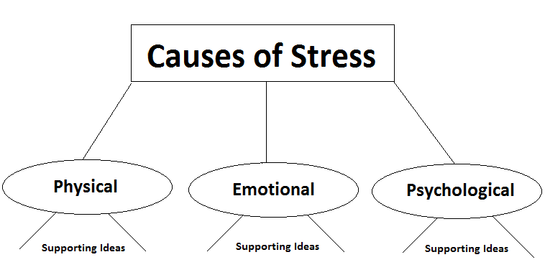
Step 2: Create an Outline
INTRODUCTION:
Lead: ______________________________________________________________________
__________________________________________________________________________________
Thesis Statement:
There are three main causes of _____________ in _____________: _____________, ________________, and____________________.
Or
There are three main effects of ______________in ______________:_____________, ________________, and____________________
BODY PARAGRAPH 1
Topic Sentence: One cause of /effect of/ reason why ___________________________________________
1. Support/Example 1 Click or tap here to enter text.
2. Support/Example 2 Click or tap here to enter text.
3. Support/ Example 3 Click or tap here to enter text.
Concluding/Transition Sentence: _____________________________________________________
BODY PARAGRAPH 2
Topic Sentence: Another cause of /effect of/ reason why _______________________________________
1. Support/Example 1 Click or tap here to enter text.
2. Support/Example 2 Click or tap here to enter text.
3. Support/ Example 3 Click or tap here to enter text.
Concluding/Transition Sentence: ________________________________________________________
BODY PARAGRAPH 3
Topic Sentence: A third cause of /effect of/ reason why ________________________________________
1. Support/Example 1 Click or tap here to enter text.
2. Support/Example 2 Click or tap here to enter text.
3. Support/ Example 3 Click or tap here to enter text.
Concluding/Transition Sentence: ________________________________________________________
CONCLUSION: (suggest a solution)
In Conclusion __________________________________________________________________________
Step 3: Write Your First Draft
Tips: Your final body paragraph should be the most convincing. It is your last chance to convince your audience that you have correctly and usefully identified the causes and/or effects. Make sure to source any information used that is not your own. Reconsider your audience to be certain your strategies meet their needs
Step 4: Re-read, re-work, revise, re-do, repeat
If possible, try to complete your essay a few days before it is due. You need to ‘take a break’ from your completed essay so that you can edit it with a fresh perspective. Try to edit your paper twice before handing it in. Keep your essay simple, follow this format and focus on supporting your thesis as strongly as you can.
Sources:
eslflow.com
http://www.eslflow.com/
Buckley, J. (2003). Checkmate. Canada: Nelson.
Davis, J. & Liss,R. (2006). Effective academic writing 3: The essay. New York, NY: Oxford University Press.

